|  |  |
| --- | --- |
| Course Name | ITD 2313 – Script Programming |
| Instructor | Mark L. Pranger |
| Student Name | Thomas Webb |
| Due date | 7/29/2025 |
| Grade | Put grade earned here |
| Grading Comments | Put instructor comments here |

Page 230-231

Part 1

Part 2

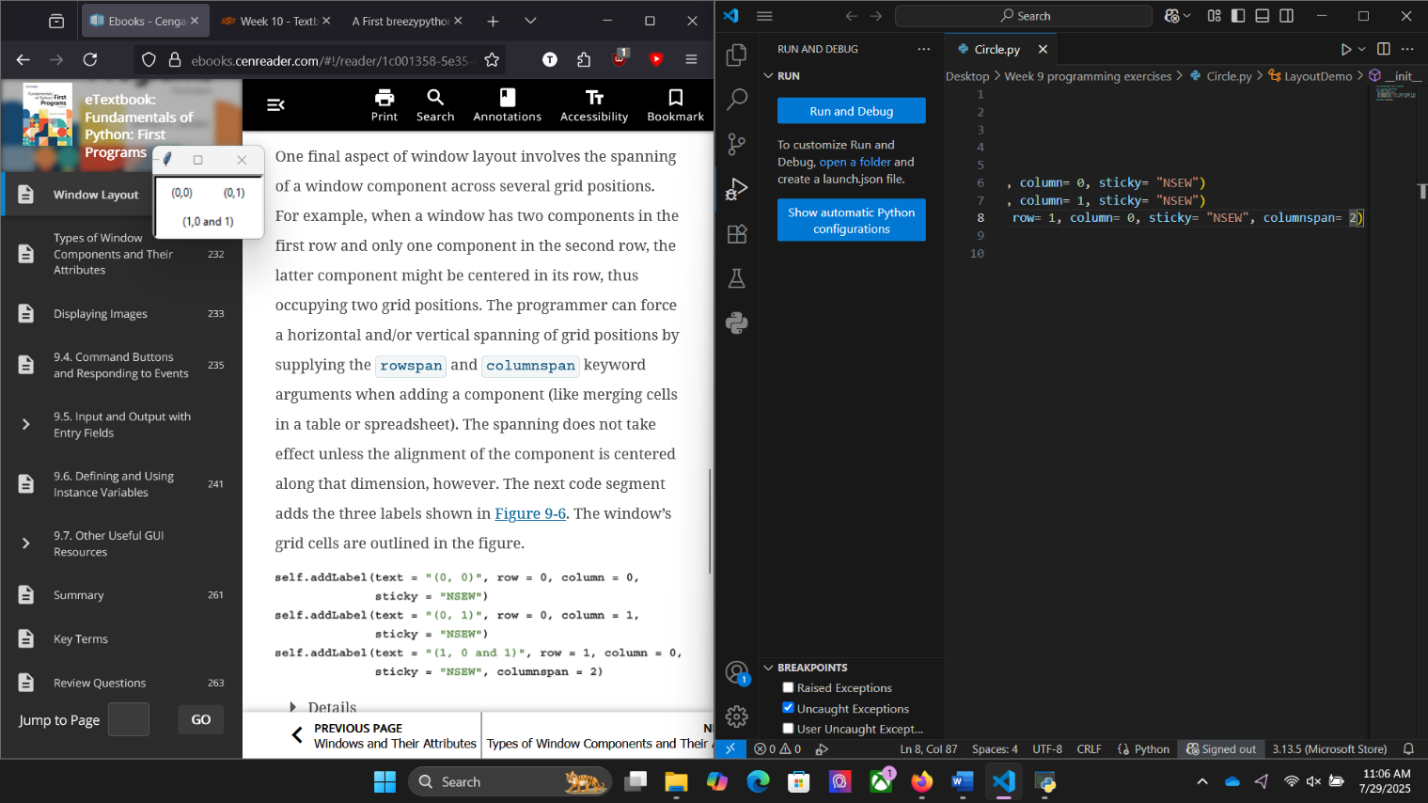

Page 233 – 234

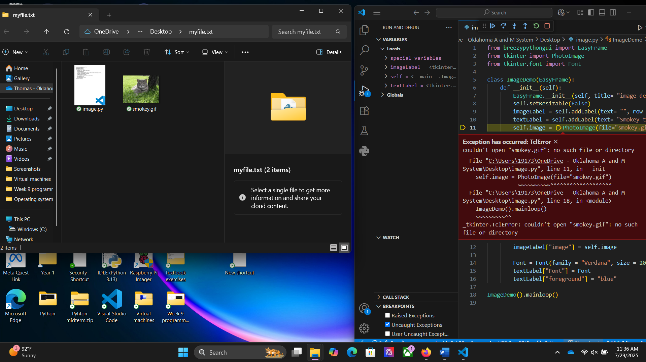

Pages 235-236

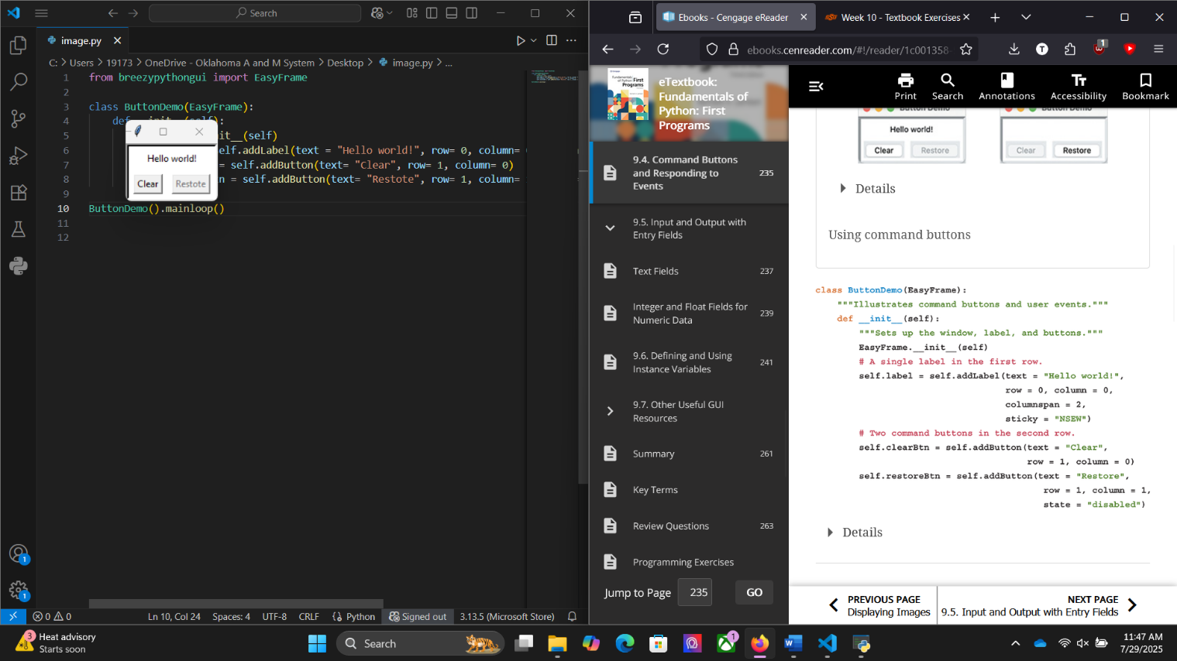

Pages 237-238

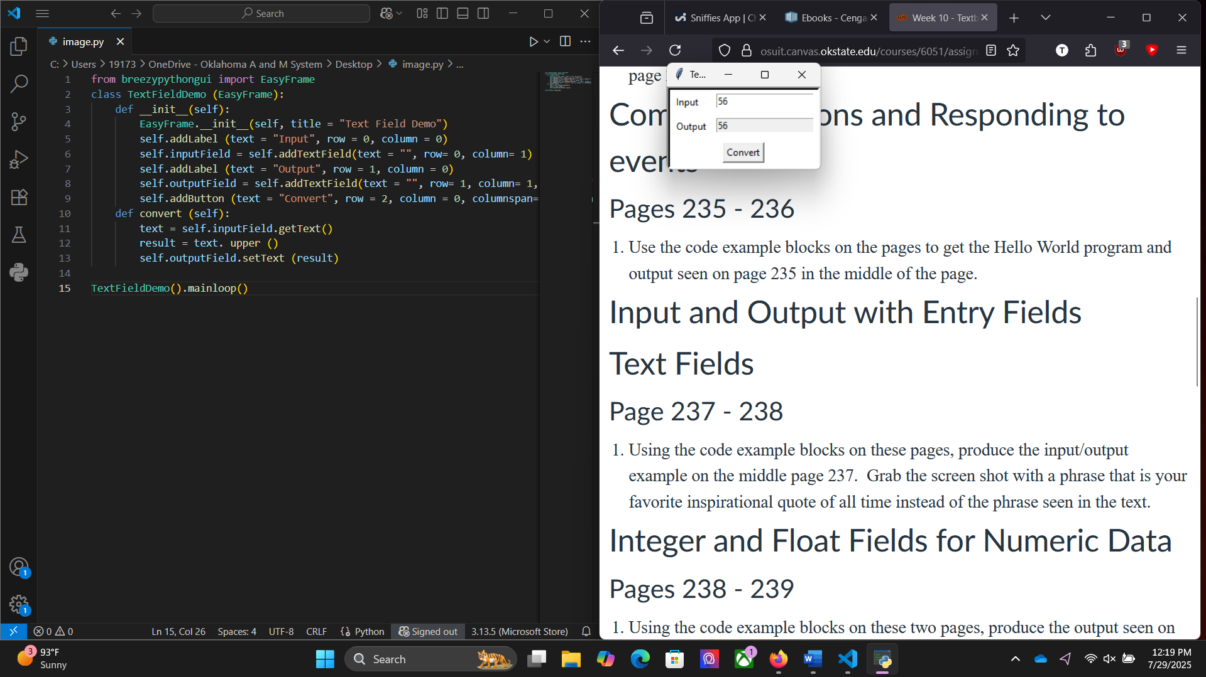

Page 238-239

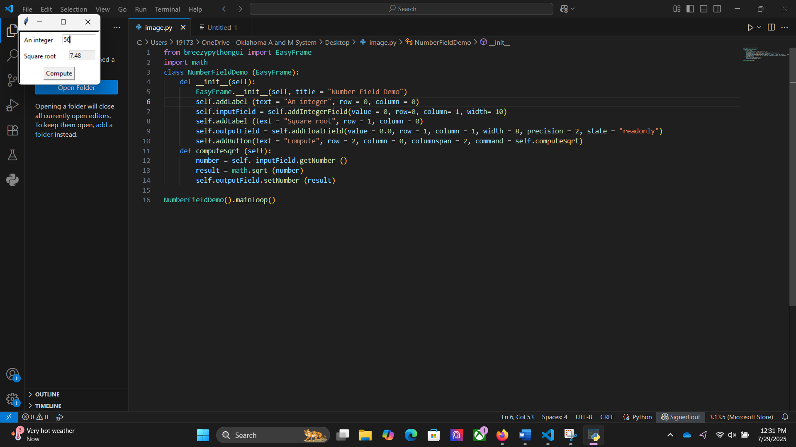

Page 245-246

